Audience: Houston Methodist Nursing Staff

Guide for using the Zebra Smartphone.

Opening Applications
Icon | Description
 | Tap the blue phone icon to open Phone WFCVoice to make calls.
 | Tap the Epic icon to open Rover app.
 | Tap the 3 dots in the upper right-hand corner and select Wireless info for troubleshooting with IT, as needed.
 | Tap the information button in the top right-hand banner to see battery and wireless information.
Back Home Current Apps
Icon | Description
 | Phone number.
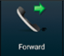 | Tap to Forward calls
 | Tap to view Vocera Generic Roles, such as charge nurses.
 | Tap to view Hospital Department entries.
 | Tap to view your Call History on this phone.
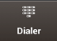 | Tap the Dialer button to dial a number and initiate a phone call.
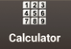 | Tap to access the Calculator.
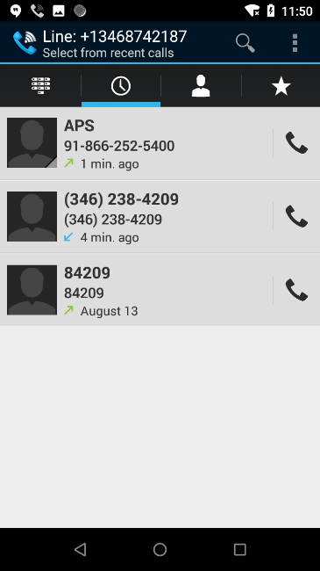
Tap Genie #8 to reach the Vocera Genie
(like on a desk phone).

Icons on the Dialer (WFCVoice)
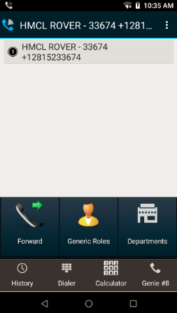

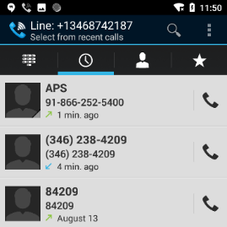
Using the Dialer (WFCVoice)

To Make a Call from Call History:

Open WFCVoice app.

Tap the History icon at the bottom.

Tap the Phone icon to place a call.

To Transfer a Call:
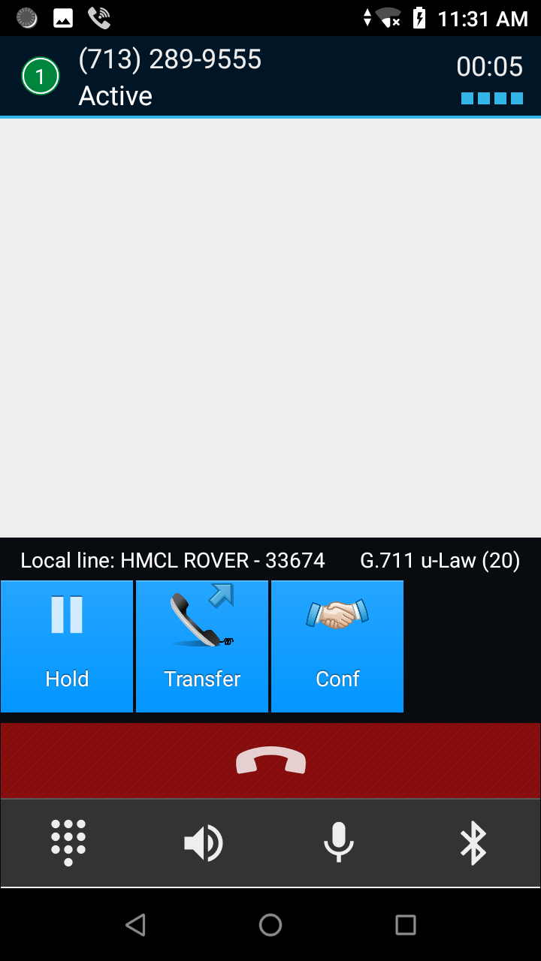
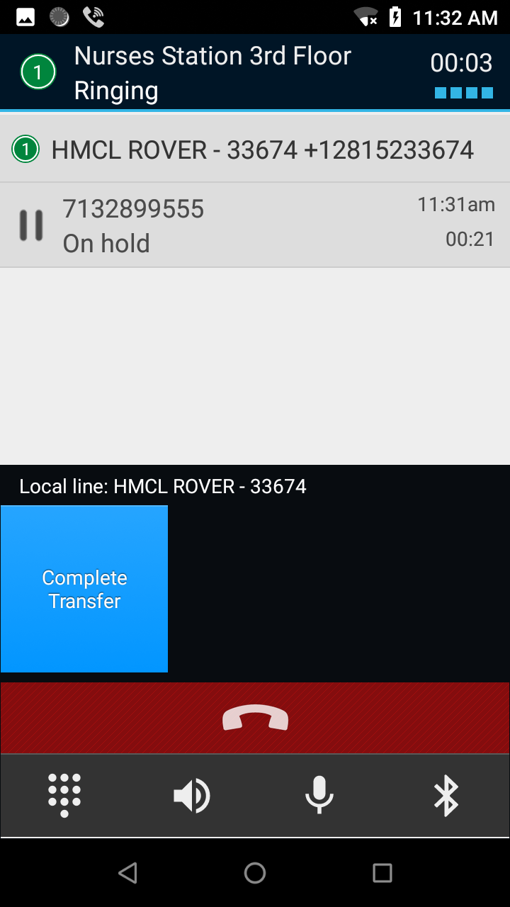
- While on an active call, tap Transfer.
- The call will automatically be placed on hold.
- You will be given the following three options (choose one):
- Tap the Dialer icon to enter a phone number, then
press the green talk button.
- Tap the Call History icon and phone next to the desired
number.
- Tap the Contacts icon for the Vocera directory of
departments and generic roles.
- Tap Complete Transfer.

To Add a Contact to Favorites:
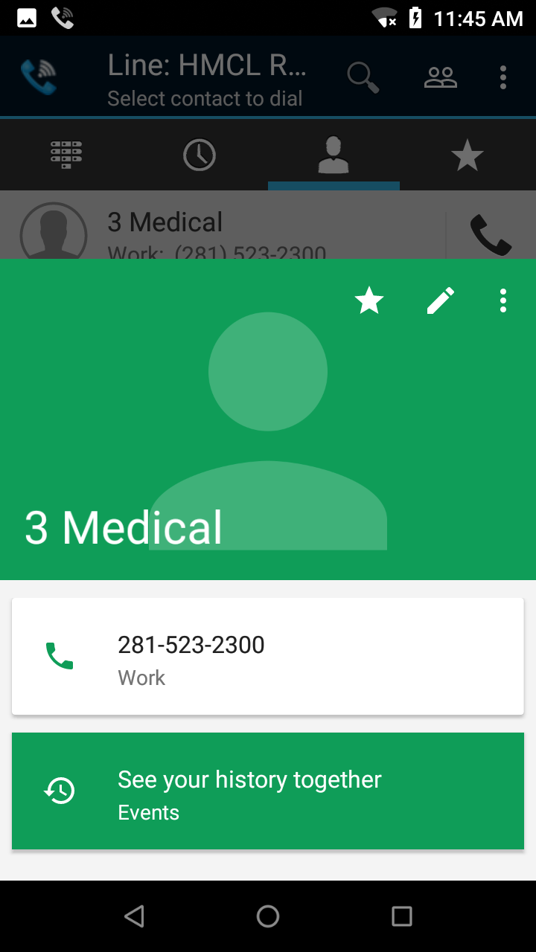
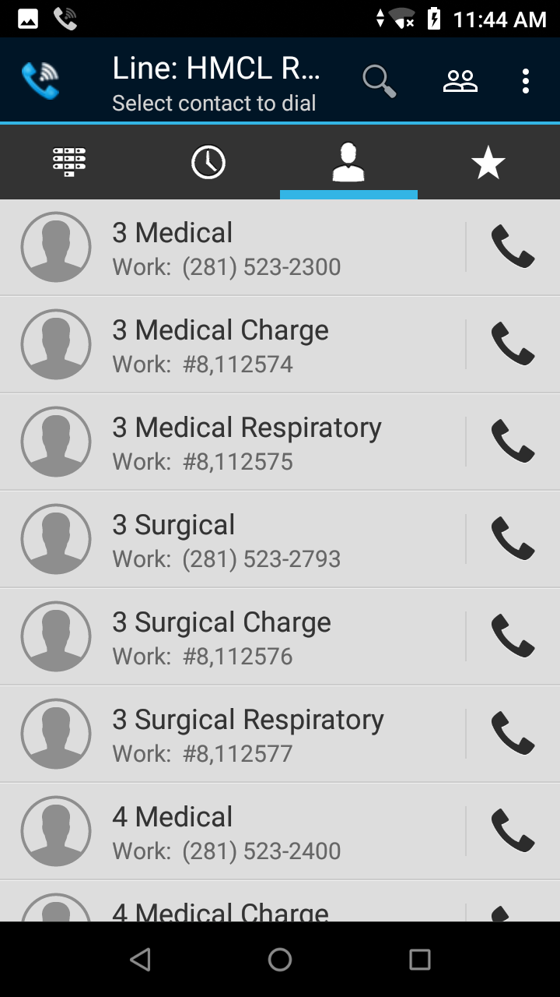
- Tap the Call History icon.
- Tap the Contacts icon at the top.
- Tap the Person icon next to the contact name.
- Tap the Star to save a contact as a Favorite.

Note: This is a shared device.
Contacts saved as favorites will be available on this device only.

Caring for the Zebra Smartphone

Cleaning and Disinfecting Guidelines:
- Make sure to always leave the battery attached to the phone when cleaning.
- To clean and disinfect, use PDI Sani-Cloth (red top) wipes located throughout the unit.
- If the patient is on Enteric Precautions, wipe the phone with PDI Bleach wipes when exiting a patient’s room.
- Never spray or pour chemical agents directly on the device.
- Use a moistened cotton-tipped applicator for smaller, hard to reach areas.
- Do not allow liquid to pool on the device.
- Allow the device to air dry.
- Some hand sanitizers contain ingredients that can be harmful to the device. To prevent damage, dry hands before touching the device or charging cradles.

Replacing the Battery:
Note: replace the battery within 90 seconds.
- After 90 seconds the device reboots and data may be lost.
- Press the Power button until the menu appears.
- Tap Battery Swap.
- Follow the on-screen instructions.
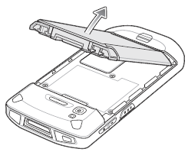
- Wait for the red LED light to turn off completely. Warning: Do not remove the battery until after the red LED light has turned off completely. Otherwise, data may be lost.
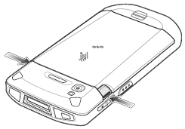
- Press the two battery latches inward.
- Lift the battery from the device.
- Insert the replacement battery, bottom first, into
the battery compartment located on the back of the
device.
- Press the replacement battery down until the battery release latches and snaps into place.
- Press the Power button to turn on the device.

Helpful Reminders

Turn the volume on high to ensure calls and notifications are heard.

Swap the battery and clean the phone at the end of your shift and as need.

Place battery in charging cradle at the end of your shift.

Introduce the phone to your patients.

The phone screen will go into sleep mode after five minutes of inactivity. When you turn the phone back on, the display will pick up on the same screen where you last left it.

Rover will go into sleep mode after 20 minutes of inactivity. For a quick log-in, scan your badge and enter your pin.

